INFO6015 – Animation 1
Mid-term Exam – Fall 2010
Instructor: Michael Feeney

The exam format:
- You may use any resources you feel are necessary to complete the exam, but you are to answer the questions on your own.

- The questions are not of equal weight. There are three (3) pages with eight (8) questions with a total of 140 marks (if my math is correct)

- The answers may be one or a combination of the following:

  - Short answer (in your own words)
  - Snippets of code
  - Complete running solutions
- CLEARLY indicate which answer goes to which question. My suggestion is that you place each answer in its own folder, named “Question_01”, “Question_02” and so on (or something equally clear). Another option is to create a Visual Studio solution and add a number of projects – one per question – to it.
- Place any written answers into a Word, RTF, or text file. Again, clearly indicate which question you are answering.
- If you are combining answers (which is likely), please indicate this with a “readme” file or some note (not buried in the source code somewhere) indicating this.
- For applications: if it doesn’t build and run, it’s like you didn’t answer it. I’ll correct trivial, obvious problems, but you need to be sure that it compiles and/or runs.
- You have until 12:00 noon on Saturday, October 30th to submit all your files to the appropriate drop box on Fanshawe Online.
- You can reach me at the office (519) 452-4430 x4798 until around 4:00 and 519-494-7569 after that (but if you call me in the middle of the night, I’ll be very annoyed...) or through e-mail (mfeeney@fanshawec.ca)

Questions:

- (15 marks) Create a timer class (C++) that can be set to change state at a certain specified interval. Details:

- The class should have a constructor or method that takes the number of seconds that need to elapse
- The class should have a method called IsTimeElapsed() that returns a Boolean. When the time is up, it returns true.
- It should use the highest resolution timer possible
- Assumes it runs on an Intel platform
- (10 marks) Why are ply models not suitable for animation (I’m looking for a specific, technical reason here).

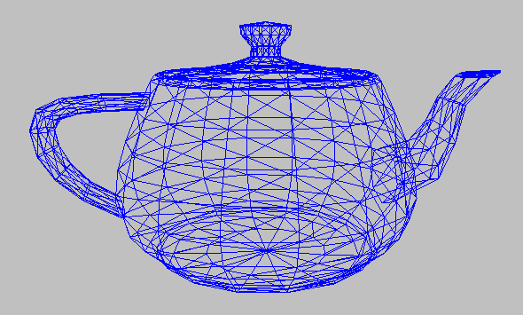
- (10 marks) Explain what an “indexed mesh” is (referring to animation models). Why are most (all?) models implemented in this fashion (again, I’m looking for a technical reason)?
- (40 marks) Create an abstract factory that instantiates a couple classes based on a base class (like CVampire and CWarewolf that inherits from a base class called CTwighlightCharacters).
- (15 marks) Make the abstract factory class in question four (4) a singleton.
- (Marks below) Create an application that outputs the following information from a BVH file (you can assume that the BVH files are all of the same format – referring to the rotation order, etc.):
  - (5 Marks) Number of bones in the model
  - (5 Marks) Number of frames in the animation
  - (5 Marks) Total animation time (in seconds)
  - (5 Marks) Frame rate (frames per second or Hz) of the animation
  - (10 Marks) The distance that the root bone travels between the start and end animation frames (note: you don’t have to take into account rotation – we are just looking at the root bone)
  - (10 Marks) The maximum distance that the root bone travels (note that his may be different from the start and end points – perhaps the actor ran around the room and ended up close to the starting point) (note: you don’t have to take into account rotation – we are just looking at the root bone)
- (10 marks) What’s the difference between a LERP and a SLERP (I’m not looking for a technical “proof” sort of answer, rather a “when you would use one over the other and why” sort of an answer)?
- (10) Why don’t you use SLERPS when using MD2 models?

That’s it

